The College of New Jersey

The Water Crisis

(subtitle)

Kaelyn DiGiamarino, Bryan Guner, Oreoluwa Nubi

FSP 124:04 Eradicate Poverty

Dr. Karen Becker

December 5, 2014

ABSTRACT

The Earth is a very complex and interconnected system. Most people are blissfully unaware of how the world around them affects their lives and decisions. Poverty in society is often regarded as disconnected. While some people are moved on a humanitarian level, most do not realize the implications poverty holds in their own lives. Despite common convention, poverty is a serious issue for the middle and upper classes. When left unchecked, poverty results in massive crime waves, transmission of diseases, substance abuse and in extreme cases national destabilization. It stands to reason that countries that reduce poverty and develop a middle class will experience social and economic prosperity. This is evidenced by the development of most western nations. Countries that wish to eradicate poverty must start by ensuring fundamental necessities in order to defeat the poverty trap. Second only to oxygen, water is the most basic necessity to survive. In order to free the poor from a vicious cycle of unemployment, governments need to provide access to clean drinking water, a necessity to maintain a healthy work force. Unfortunately most impoverished nations lack the infrastructure and are subject to corruption within the government. A multilateral approach must be chosen to address the various obstacles involved in providing a developing nation with drinkable water. In the case of Ethiopia, water scarcity and quality are crippling the economy and the people. The first step in providing Ethiopia with accessible drinking water is to address the corruption that goes on within the government. Corruption might be obvious on a national level, but the individuals who partake in it conceal their actions. The best way to solve this dilemma on a national level is to bring it down to a personal level. This is done by establishing a department of transparency responsible for collecting complaints, generating statistics, and exposing the individuals responsible for corruption to the public and media. Corruption might prevent a country form allocating resources to public health, but in the case of Ethiopia, the government and private sector lack the technical know-how and logistical capability to solve the nation’s water issues. Our solution to this water pandemic draws its inspiration from the Barefoot College. The Barefoot College is a school in India that trains African women in the field of solar engineering. This enables the women to provide a valuable service while establishing a career for themselves. A school that trains Ethiopian citizens to become water sanitization engineers would allow the country to simultaneously emerge from the poverty trap and establish a new job sector. Governments, companies, and especially people, are reluctant to give their time and money to a cause that they do not stand to gain from. What most don’t realize, is that poverty costs society far more over the long run than it costs to eradicate. When viewed from a holistic perspective, fixing poverty becomes something we should do for ourselves, rather than a moral responsibility.

(Need **Key Words** listed here. Abstract needs to be cut down in length—should be 250 words)

Table of Contents

1. Overview

A. Introduction……………………………………………………………………………..

B. Water as a Necessity…………………………………………………………………….

C. Problem’s Associated with Lack of Water………………………………………………

2. The Water Crisis

A. Poverty’s Effect on Society……………………………………………………………..

B. Water’s Effect on Poverty………………………………………………………………

3. The United States versus Ethiopia

A. The United States……………………………………………………………………….

B. Ethiopia…………………………………………………………………………………

C. The Difference………………………………………………………………………….

4. NGO’s

A. NGO #1…………………………………………………………………………………

B. NGO #2…………………………………………………………………………………

C. NGO #3…………………………………………………………………………………

5. Solutions

A. Solution Options………………………………………………………………………..

B. United States Solutions…………………………………………………………………

C. Ethiopian Solutions……………………………………………………………………..

D. Our Solution……………………………………………………………………………

"Thousands have lived without love, not one without water." (Wystan Hugh Auden). When someone is asked if they need anything they almost always think of objects they want. This question is not meant to be literal. If it was, the response would unequivocally be air, water, food, and sleep. Wystan Auden makes use of literalism in an almost comical betrayal of societies expectation that love would be valued first and foremost above all other human “necessities”. This witticism was not intended to ridicule people’s craving for love and acceptance, but rather to draw attention to basic human necessities that are nearly forgotten in first world society. In developed countries like America, individuals spend most of their lives in pursuit desires. In the span of a few generations the people of western nations have forgotten what it means to survive. Inhabitances of developed nations do not “survive”. Rather, they “live” as technological innovation has allowed them to transcend prioritizing their biological needs. While having a lucrative career, a house with a white picket fence, and a two-child family are staples of American culture, they are not in fact needs. Without water, people quickly experience compromised bodily function, culminating in death after approximately three days of unabated dehydration. In developing nations, people endure water scarcity and contamination. A day or two of dehydration renders citizens unable to function let alone work; without income, it becomes very difficult to obtain the sustenance necessary to stay in working condition. This series of unfortunate events is self-perpetuating, known as the Water Poverty Trap. This vicious cycle is largely responsible for the high unemployment rate in Ethiopia, which has fluctuated between 18% and 26% in the last few decades. For comparison’s sake, the United State’s Great Depression ranged between 15% and 25% unemployment for a period of three years. In America, the Great Depression is considered to be one of the darkest times in the young nation’s history. While for a brief period it experienced crippling unemployment, U.S. citizens still enjoyed an immensely higher quality of life due to their developed infrastructure than Ethiopian citizens experience to this day. The great depression was a product of mass panic and American economic policy with Europe; Ethiopia’s plight is a result of the poverty trap and is therefore far more detrimental. In the United States, people could not find jobs during the depression. In Ethiopia people are not able to do the jobs necessary to stimulate the economy and sustain themselves and this is where the true source of their poverty lies.

**2. THE WATER CRISIS**

2A. Poverty’s Effect on Society

Still waiting for draft

2B. Water’s Effect on Poverty

Still waiting for draft

**3. THE UNITED STATES VERSUS ETHIOPIA**

3A. The United States

The United States has a population of 316.1 million people (www.census.gov); of these people, 80% are urbanized (www.unicef.org). People in the United States predominantly make a living through jobs in manufacturing, health service, education, wholesale and retail trade, and government. The geographic location of the United States is one with varied topography and mostly temperate weather. Although the United States is involved in conflict with other countries, it all takes place overseas. There is no warfare within the borders of the United States. Because of the urbanized population, various jobs offered, and ideal geographic location, the majority of the United States lives above the poverty line. 13.6% of Americans live below the poverty line (http://surface.syr.edu); while this number is still larger than it should be, the United States is nowhere near the poverty level of developing countries.

Just like the poverty level, the water crisis in the United States is not as pressing as it is in developing countries. Nonetheless, it is still present. Environmental issues chiefly impede the water quality in the United States; examples of this are high chemical corrosion, fracking, and chemical spills. Moreover, rusty pipes and the inability to pay a water bill are also plaguing issues that cause lack of water resources and cleanliness.

In East Orosi, California, it is a struggle to find clean drinking water. The tap water is a risk to drink, as it contains nitrates that can cause “blue baby syndrome”, a potentially fatal blood disorder that cuts off an infant’s oxygen supply. The town is made up of mostly low-income Latinos, and more than half live below the poverty line. There is a sense of neglect in the air. With no sidewalks, streetlights, parks, or playgrounds it seems as if the town has been forgotten. Moreover, the residents pay for tap water that is not fit to drink.

This environmental justice problem is not unique to East Orosi. Of eight counties in the San Joaquin Valley, approximately 5,200 people had drinking water that surpassed federal nitrate standards, and an additional 449,000 had medium levels varying from just below the limited to half the maximum allowed (wwwscientificamerican.com).

It is not infrequent that water systems in this area of California repeatedly exceed safety level amounts of coliform bacteria, nitrates, or arsenic. Nitrates are byproducts created by unclean farming practices. Nitrogen is found in synthetic fertilizers, animal manure, septic tanks, and wastewater treatment plants. Use of these products leads to an end result of contaminated water supplies. According to the University of California, agriculture is the reason for 96% of water contamination in these areas (www.scientificamerican.com).

This contamination affects both the poor and the wealthy. However, the wealthy have the resources and means that give them the mobility needed to avoid the situational problem. The rich are able to move to a new town, rent a hotel to stay at, or travel to stay with family. The poor do not have these resources, and are therefore stuck with no choice but to stay in their contaminated hometown. This contamination problem has been going on for years and so the majority of wealthy families have moved out of the contaminated areas. This leaves only the poor, which further hurts the wellbeing and chance of the town’s recovery.

3B. Ethiopia

On the other end of the spectrum is Ethiopia. Ethiopia is a country located in the Horn of African with a population of 91,730,000 (www.charitywater.org). Ethiopia has faced famine, drought, political instability, and war throughout its history. Although peace has returned, the nation still remains weak both developmentally and in its infrastructure. 43.4 million people in Ethiopia—over half of the population—do not have access to safe water, and over 67 million people do not have access to adequate sanitation (www.wateraid.org). Due to its geographic location, Ethiopia faces extended period of droughts, famines, and conflicts. These obstacles seriously impact the health and life expectancy of the country’s citizens. It is not unlikely for a child in Ethiopia to die before the age of five.

29.6% of Ethiopians live below the poverty line, a percentage largely impacted by a water crisis (http://data.worldbank.org). Most people of Ethiopia make a living through farming, a task they cannot perform without water to grow the crops. In addition to droughts, challenges also arise through lower water tables and the poor roads that make it difficult to reach remote villages. The majority of rural families in Ethiopia survive on less than five liters of water per day, which they have to walk up to four hours to collect. 5 liters is comparable to about 10 water bottles. This measly amount of water must be split between an entire family to hydrate and bathe each individual, wash dishes and laundry, feed livestock, and sustain farming.

Hadis Tekele is a 63-year-old priest living in Asegeda, Ethiopia, where rainfall is close to non-existent in the months of September to June. The only water available to the small community is located two miles away at a hand pump installed by the local government, accessible only by an hour-long trip on foot. Collecting water is immensely time-consuming—time that could be spent elsewhere. Hadis, a member of the community’s sanitation committee, explained, “If we had water nearer our houses, we will have more time for different activities such as farming” (www.wateraid.org). Due to lack of easy access to water, people of Asegeda use what little they can collect for drinking and have no surplus to use towards their personal cleanliness or health. With no water to grow crops, a person that relies heavily on his or her agriculture will have no way to feed or support their family. The people of Asegeda, Ethiopia are trapped in poverty by this unquenchable thirst.

The water crisis in Ethiopia is a part of the poverty trap, therefore making it a generational problem. When a child is born into a community filled with families with limited resources, upward intergenerational mobility—when a person moves upward on the social class ladder from where there parents are—is very difficult, if not nearly impossible.

The country of Ethiopia relies heavily on agriculture. Agriculture accounts for 41% of Ethiopia’s gross domestic product (GDP), 80% of exports, and 80% of the labor force (www.tradingeconomics.com). It is impossible for one to farm without water. The limited availability of clean water restricts the potential profit from agriculture. This proves that the water crisis in Ethiopia not only affects each individual citizen, but also the country as a whole.

3C. The Difference

The severity of the water crisis in the United States, a developed urbanized country, versus Ethiopia, an undeveloped rural country, is clear. The difference is well defined when countries’ life expectancy is compared against their improved water sources. Using GapMinder, these two factors can be compared on a scatter plot graph as seen in Figure A below. The United States can be found in the upper right hand corner of the graph. The United States had an improved water source of almost 100%, and a high life expectancy that fell between 75 and 80 years of age in the year of 2002.

Ethiopia is plotted on the left hand, upper third of the graph. The percent of improved water sources falls short at only 30-35%. The life expectancy of citizens in the country was only about 50-55 years of age. Ethiopia was in close company by the remaining countries of sub-Saharan Africa. There is a definitive line between the sub-Saharan African countries and the rest of the globe. The trend on the graph reveals a close correlation between clean water and the long-term health of an individual.

Furthermore, an even stronger correlation can be found when looking specifically at diarrheal deaths in relation to improved water sources. Diarrhea is a very preventable illness. However, the illness is most frequently a consequence of drinking unclean water. Therefore, it is logical that a country with less access to clean water will have more cases of diarrhea.

It is somewhat of a commonality for Ethiopian children to die before they reach the age of five; a large number of these deaths are due to diarrhea. According to GapMinder, in 2008, there were almost 100,000 diarrheal death in children 1-59 months old in Ethiopia. In comparison, there were about 50 diarrheal deaths of children the same age in the United States. This can be seen in Figure B.

Figure A.

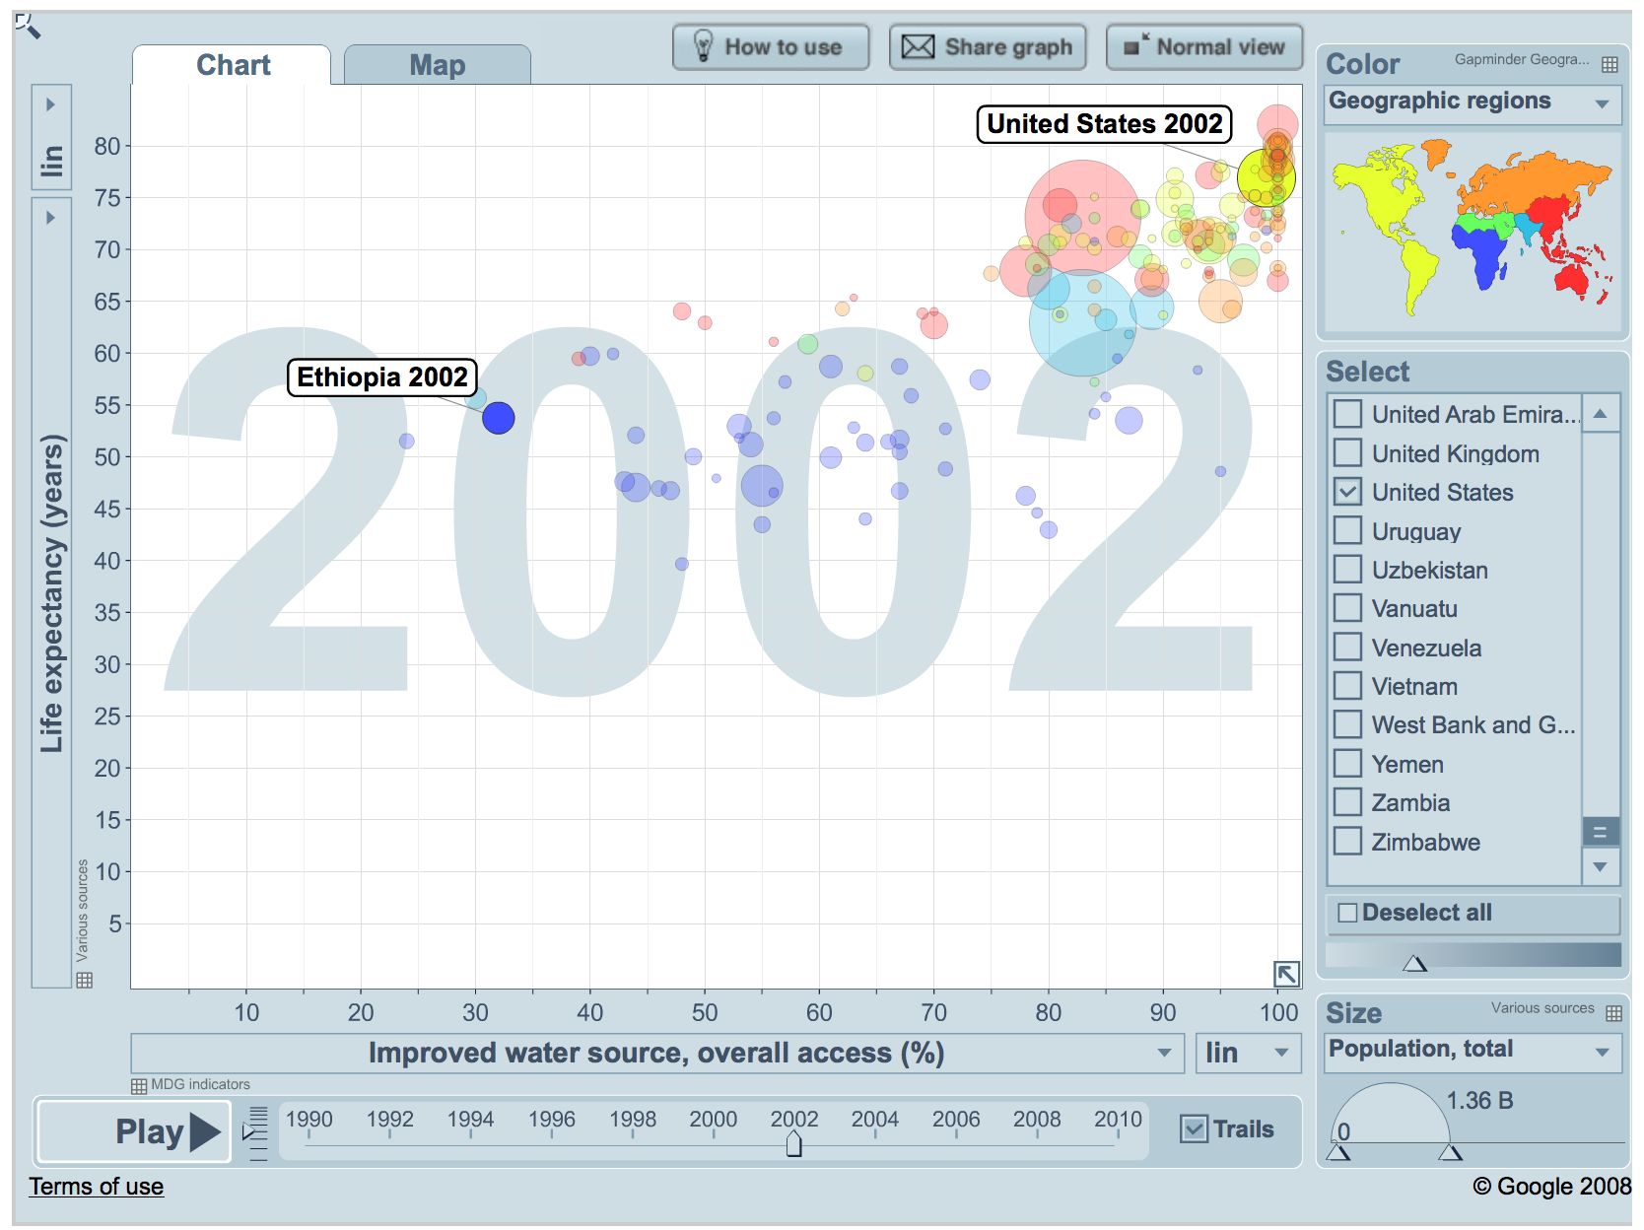  
www.gapminder.org

Figure B.

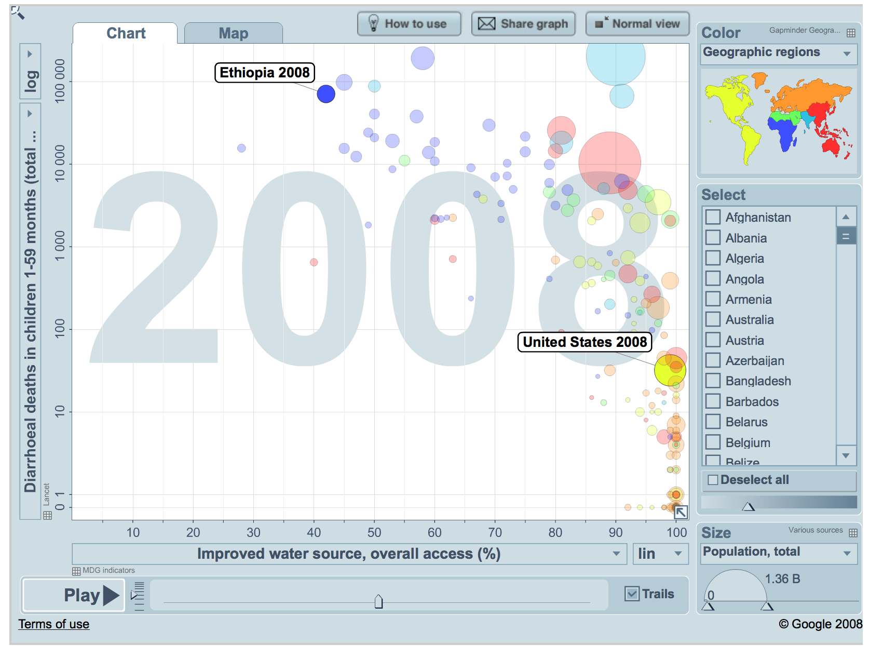

www.gapminder.org

In the United States the water crisis is a consequence of poverty, whereas in Ethiopia it is just one element of the poverty trap. Because the water crisis in the United States is different than the water crisis in Ethiopia, the solution needed is also different. There is no “one size fits all” solution to the water crisis.

**4. NGO’s TAKING ACTION**

Still waiting for draft

**5. SOLUTIONS**

5A. Solution Options

Solutions to provide communities with fresh water are abundant and come in various forms. Some solutions involve tapping into the earth. Wells are an example of this. Wells can either be hand dug or drilled, both of which reach fresh aquifers below the ground. Integration of solar powered water wells is another option that is both eco friendly and environmentally safe. The system pumps water out of a water source, purifies it, and sends it to the local village. This effectively creates running water in areas without strong infrastructure and does not require the human labor of traditional merry go round pumps. Piped systems are networks of pipes that supply water to different community tap stands. Spring protectors are systems that capture and safely store pure water from a natural spring. Taking advantage of rainfall is another possibility. Through rainwater catchments and gravity fed systems, rainfall can be collected and stored in a sanitary holding tank.

The Life Straw is a water purifier option that is not only an already thriving solution, but also an entrepreneurial invention that has turned in economic profits. This straw requires no electrical power, batteries, replacement parts, running water, or piped-in water supply. The Life Straw has an easy to clean pre-filter and purification cartridge that removes bacteria, viruses, and protozoan parasites found in water.

5B. United States Solutions

Solutions to fix the United States water issues are not as extensive and difficult compared to developing countries. The United States needs to upgrade and repair the old and out-of-date pipes to water and sewer systems to ones that are more eco-friendly and efficient. For example, in New Jersey some old urban areas have pipes that date back to the nineteenth century. In addition, more government legislation should be passed to ensure clean water in the U.S. such as The Clean Water Act. “The CWA establishes the basic structure for regulating discharges of pollutants into the waters of the United States and regulating quality standards for surface waters” (epa.gov). Pollution control programs such as the Environmental Protection Agency can take control in bettering the water standard and ensuring pollution control.

(Elaborate on CWA and EPA)

5C. Ethiopia Solutions

Corruption in government is one of many poverty causes in developing countries. Specifically pertaining to water, corruption is rampant and extensive. Corrupt officials are pocketing funds that are meant to fix water issues. Projects for water management, irrigation, and dams are costly and therefore targets of money-hungry officials. Despite the fact that Ethiopia is one of the fastest-growing economies in Africa, it is still one of the world’s poorest countries. Corruption is the explanation of this disparity (transparency.org).

Ethiopia contains the Federal Ethics and Anti-Corruption Commission. Their mission is

“to ensure that the country's resources go to the desired development projects by expanding ethics and anti-corruption education; examining the practices and working procedures in federal public offices and enterprises and thereby plugging loopholes that are believed to be conducive for corruption; exposing, investigating and prosecuting alleged corruption offences where they are committed in federal public offices and public enterprises, or in the regional offices related to subsidies granted by the Federal Government” (feac.gov.et)

The FEAC would take action to better the government and ensure that funds are appropriated to the right place. Furthermore, the book *Designing A World That Works For All,* describes a government solution called waterment. Waterment is a government agency that initiates laws and regulations for water usage in the home, industry, and agriculture. The main focus is water conservation. Since Ethiopia frequently struggles with drought, starting with water conservation is the best option. Additionally, Waterment ensures clean water will be provided to all. The “Waterment Strategy” describes the use of the Kisii Water Filter, an economical filter that removes most bacteria, and the preservation and care for the local wells. The water crisis will only becomes less of a problem when the government steps in to help.

5D. Our Solution

Still waiting for draft